# Chapter 3

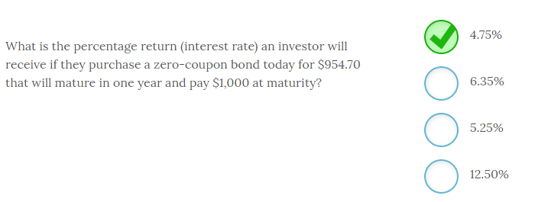

The percentage return (interest rate) an investor will receive if they purchase a zero-coupon bond today for $954.70 that will mature in one year and pay $1,000 at maturity is **4.75%**.

Given the time value of money, we know that the $1,000 we expect to receive in the future (FV) has a value today (PV) of $954.70. Since we know that the holding period is only one year, you can easily calculate that rate with your financial calculator using the following key strokes:

PV = -954.70; FV = $1,000; N=1; PMT = 0; CPT I/Y and you will get 4.75%

In addition, you know that the rate will be somewhere close to 5% since the $45.30/$954.70 is slightly less than 5%. For one year periods, you can use this simple method to approximate the rate. The other interest rate choices above are arbitrary.

In later modules, you will discover this calculation is known as the yield to maturity or YTM. It is also the same process, we will use to calculate an internal rate of return (IRR).

-------------------------------------------------------------------------------------------------------------------------------------------------------------------------------------------------------------

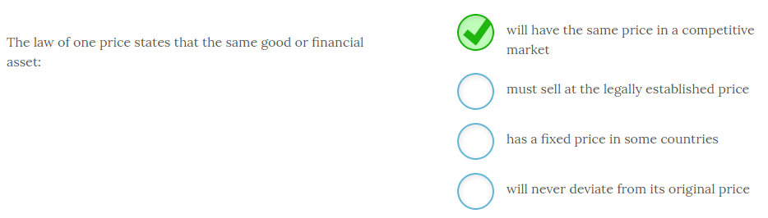

The law of one price states that the same good or financial asset **will have the same price in a competitive market**.

The reason this is true is not because the law requires this condition to hold, or that a country fixes a specific price, but that the act of arbitrage will keep prices equal. If the selling price is higher than the buying price an arbitrager will simultaneously buy and sell the asset, which moves the prices back to the same level. In competitive markets, these price discrepancies will be very short lived.

-------------------------------------------------------------------------------------------------------------------------------------------------------------------------------------------------------------

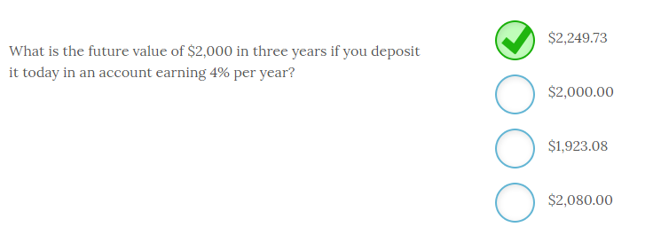

The future value of $2,000 in three years if you deposit it today in an account earning 4% per year is **$2,249.73**.

You can calculate this using the formula FV = PV(1 + i)n where, i = interest rate and n = number of periods. Therefore, FV = $2,000(1 + .04)3 = $2,249.73. The future value will always exceed the present value for any interest rate above zero. The $2,000 lump sum will be worth $2,080 in one year assuming a 4% return.

-------------------------------------------------------------------------------------------------------------------------------------------------------------------------------------------------------------

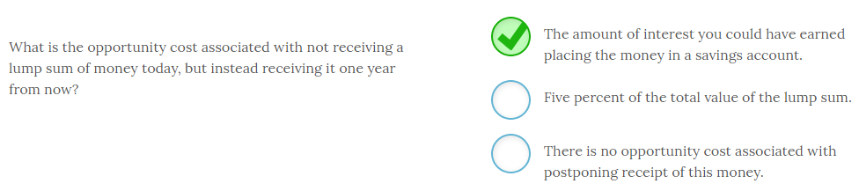

The opportunity cost associated with not receiving a lump sum of money today, but instead receiving it one year from now is equivalent to **the amount of interest you could have earned placing the money in a savings account**.

The opportunity cost is the cost associated with the next best option. In this case, you could have received the money today and earned some rate of return. That foregone return is the opportunity cost. Since the lost income depends on the market rate of interest at the time, we have no way of knowing whether it is 5% or not. As long as the market rate exceeds zero, holding all else constant, there will be an opportunity cost associated with postponing receipt of this cash flow.

The lost opportunity for investing these funds is one of the primary reasons there is a time value of money. Another potential opportunity cost is the cost associated with the loss of purchasing power due to inflation. If you received the money today, you could spend it and buy more goods and services with that amount than you would be able to buy with that amount in one year, assuming an inflation rate greater than zero.

-------------------------------------------------------------------------------------------------------------------------------------------------------------------------------------------------------------

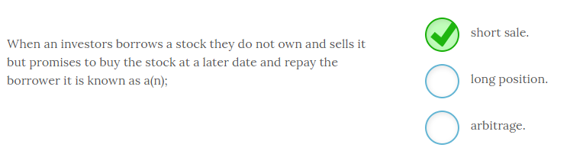

When an investor borrows a stock they do not own and sells it with a promise to buy the stock at a later date and repay the borrower it is known as a **short sale**. Investors who believe a stock will fall in value may short the stock (i.e. borrow it and sell it) and buy the stock after it falls in value. The investor will profit based on the difference between the selling price and the buying price minus any transaction costs.

An investor has a long position when they buy a stock to sell at some later date. Arbitrage occurs when you buy and sell simultaneously and therefore incur no risk.

-------------------------------------------------------------------------------------------------------------------------------------------------------------------------------------------------------------

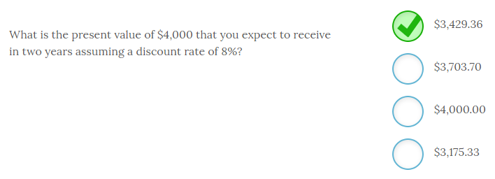

The present value of $4,000 that you expect to receive in two years assuming a discount rate of 8% is equal to **$3,429.36**.

The present value would be $3,703.70 if you expected to receive the cash flow at the end of one year and $3,175.33 if you expected to receive the $4,000 at the end of three years. The easy method to make the calculation is to use a financial calculator and input the following keystrokes:

FV = -$4,000; N = 2; I/Y = 8%; CPT PV

-------------------------------------------------------------------------------------------------------------------------------------------------------------------------------------------------------------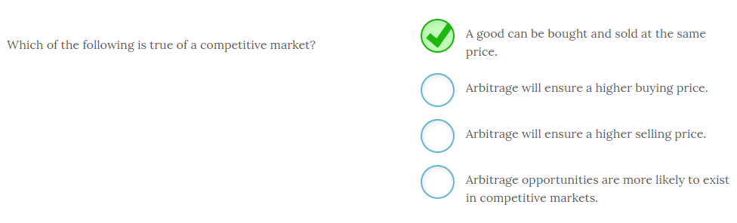

In a competitive market, **a good can be bought and sold at the same price**.

The valuation principle in finance ensures that there is only one price for a product in a competitive market. Arbitrage will eliminate any deviations from one price as soon as it is identified. If you can buy at a lower price and sell at a higher price, there will be an increase in demand that pushes the buy price higher and an increase in supply at the higher selling price that pushes it lower until a new equilibrium price is established. The quest for profits by arbitragers will cause the prices to converge instantly. So, in a pure competitive market arbitrage opportunities will be rapidly eliminated and the buy and sell price will be one price.

Arbitragers buy low and sell high to make a profit and quickly eliminate any price differential through this activity. For it to be true arbitrage, the buying and selling must happen simultaneously. If the asset is held for a period of time, it is not a riskless transaction and becomes investing or speculation.

-------------------------------------------------------------------------------------------------------------------------------------------------------------------------------------------------------------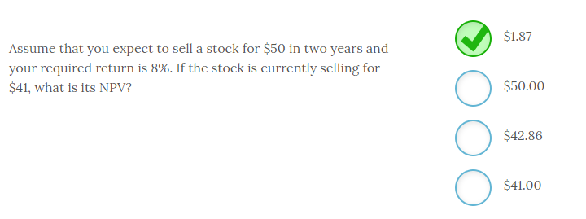

Assume that you expect to sell a stock for $50 in two years and your required return is 8%. If the stock is currently selling for $41, the NPV is **$1.87**.

The only expected cash flow in this example is the forecasted selling price of the stock which is $50. So, the NPV is equal to the present value of the expected cash flows minus the current price which is: NPV = [$50/(1.08)2] - $41 = $42.87 - $41 = $1.87.

Keep in mind that if these cash flows were certain and the market was competitive, the stock should have an NPV = 0. However, forecasting future selling prices or cash flows is not an exact science.

-------------------------------------------------------------------------------------------------------------------------------------------------------------------------------------------------------------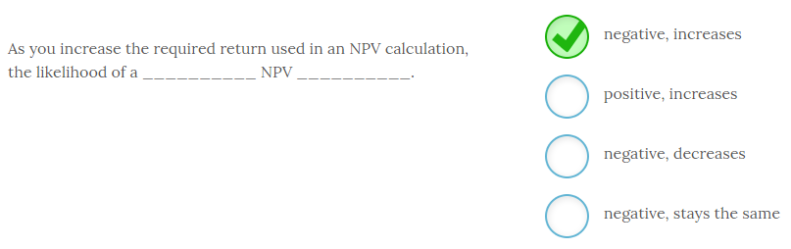

As you increase the required return used in an NPV calculation, the likelihood of a **negative** NPV **increases**.

Increasing the required return decreases the present value of the cash flows. This, in turn, decreases the NPV which increases the chance that the NPV will be negative. Higher discount rates always reduce the present value of the cash flows.

The discount rate used in the NPV calculation should be commensurate with the level of risk of the project. That way a higher risk project has a lower likelihood of being accepted, all things equal.

-------------------------------------------------------------------------------------------------------------------------------------------------------------------------------------------------------------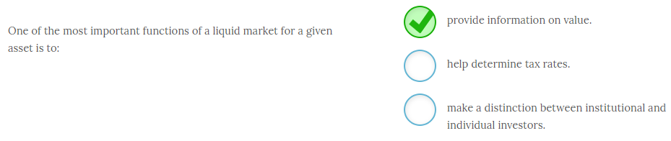

One of the most important functions of a liquid market for a given asset is to **provide information on value.** Competitive markets need a large number of buyers and sellers in order to provide sufficient liquidity. When markets are liquid they provide a clear signal of the value of an asset that thinly traded or illiquid markets cannot provide. Competitive liquid markets are therefore critical since the goal of the firm is to maximize shareholder wealth and the stock price is the metric managers monitor to see if they are achieving their goal.

Governments, not markets, determine tax rates. Institutional investors and individual investors both benefit from liquid markets but there is no distinction made between these investor types.

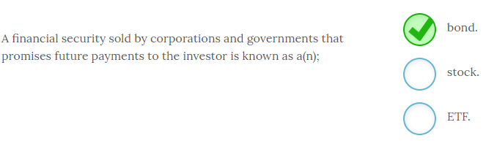

A financial security sold by corporations and governments that promises future payments to the investor is known as a **bond**. Bonds are essentially IOUs that promise to pay investors the face value of the bond at some future date. In most cases they also pay investors annual or semiannual interest payments.

Stocks and ETF (exchange traded funds) make no promise of repayment and are also not issued by governments.

Some bonds, known as zero coupon bonds or zeros, pay no interest and are simply sold at a discount.

-------------------------------------------------------------------------------------------------------------------------------------------------------------------------------------------------------------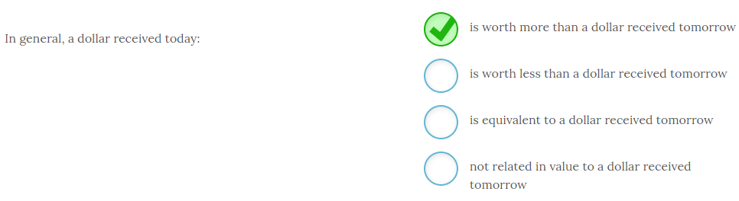

In general, a dollar received today **is worth more than a dollar received tomorrow**.

As long as there is a positive interest rate, you can invest money you have today and it will increase in value. Because of the opportunity cost of this foregone interest earned, you would place a higher value on receiving the dollar today instead of tomorrow or next year. This difference in value over time is known as the time value of money.

This concept should be intuitive to you. Most of you would prefer to receive $100 today instead of $100 in one year. Why? Because of the time value of money. Even if you did not invest it, but instead wanted to spend the money, you would prefer it now since inflation would reduce the purchasing power of the $100 you expect to receive in one year. You would rather get it today and spend it or invest it because money has a time value.

-------------------------------------------------------------------------------------------------------------------------------------------------------------------------------------------------------------

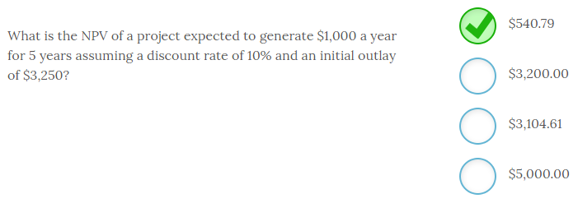

The NPV of a project expected to generate $1,000 a year for 5 years assuming a discount rate of 10% and an initial outlay of $3,250 is **$540.79**.

The easiest way to solve this problem is to use a financial calculator with the following inputs:

PMT = -$1,000; N = 5; I / Y = 10%; CPT PV. PV is equal to $3,790.79 - $3,250 = $540.79. Since the NPV is positive, the project should be accepted.

Remember that when NPV = 0 the project generated a return that was exactly equal to the required return.

-------------------------------------------------------------------------------------------------------------------------------------------------------------------------------------------------------------

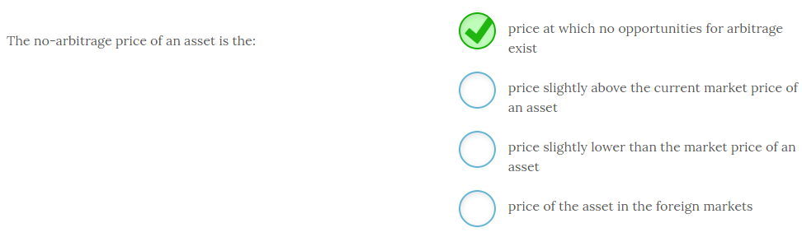

The no-arbitrage price of an asset is the **price at which no opportunities for arbitrage exist**.

At any asset price above or below the current market price, there would be an opportunity to simultaneously buy and sell the asset to make a profit. Only when the price is exactly at the point where no arbitrage profits exist is the asset priced at the no-arbitrage price. Foreign markets may present arbitrage opportunities depending on their level of competitiveness.

In a competitive market, the no-arbitrage price will be the prevailing market price.

-------------------------------------------------------------------------------------------------------------------------------------------------------------------------------------------------------------

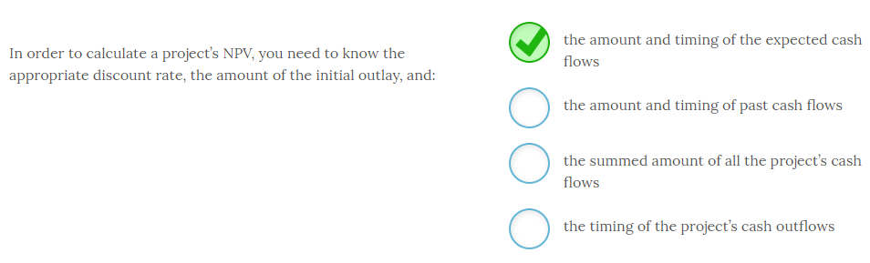

In order to calculate a project’s NPV, you need to know the appropriate discount rate, the amount of the initial outlay, and **the amount and timing of the expected cash flows**.

To calculate an NPV, you need to calculate the present value of the project’s expected cash flows. In order to make that calculation, you need to forecast the amount and timing of these cash flows. The next step is to subtract the initial outlay from this amount and see if the result is positive or negative. If the NPV is positive, you should accept the project since it generates your required return at a minimum.

Past cash flows are irrelevant since the NPV should be based on future cash flows. The timing of when these cash flows will occur is critical to the present value as well, so summing the cash flows is incorrect since you will lose the timing in that process. And, you need the timing of all cash flows, not just outflows.

-------------------------------------------------------------------------------------------------------------------------------------------------------------------------------------------------------------

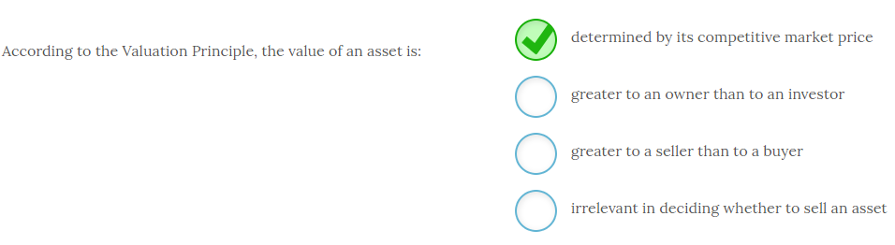

According to the Valuation Principle, the value of an asset is **determined by its competitive market price**.

Anyone conducting cost vs. benefit analysis should use the competitively determined market price. If the benefits are greater than the costs, then an asset should be acquired. As it relates to the firm, this action will increase shareholder wealth.

The only asset value that is relevant is the one determined by the competitive market, and this price is the same to the buyer and the seller. This is the price that should be used for decision making purposes.

The Valuation Principle is an application of the marginal cost vs. marginal benefit analysis you learned about in economics. The decision rule is still the same. If the benefits are greater than the costs, it is a good decision. In this case, good decisions add value to the firm in the form of increased shareholder wealth.

-------------------------------------------------------------------------------------------------------------------------------------------------------------------------------------------------------------

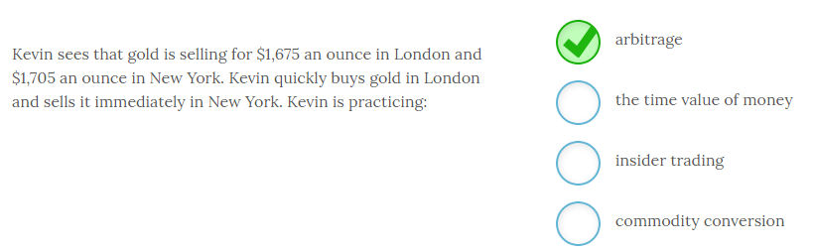

Kevin sees that gold is selling for $1,675 an ounce in London and $1,705 an ounce in New York. Kevin quickly buys gold in London and sells it immediately in New York. Kevin is practicing **arbitrage**.

Arbitrage is the immediate buying and selling of some asset where the arbitrager finds a price discrepancy. Since this activity occurs instantaneously, the time value of money is not a factor. Kevin is also not an insider and is trading with publicly available information. No commodities are converted in this practice.

This practice will cause the price to converge in both markets and the opportunity to profit from this transaction will rapidly disappear as enough buyers and sellers take advantage of it and the prices become equivalent.

-------------------------------------------------------------------------------------------------------------------------------------------------------------------------------------------------------------

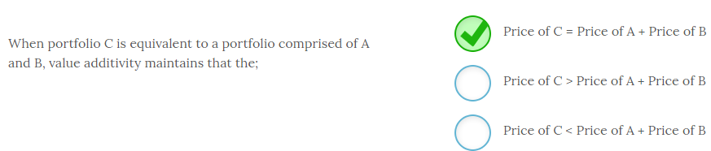

When portfolio C is equivalent to a portfolio comprised of A and B, value additivity maintains that **Price of C = Price of A + Price of B**. The law of one price states that value is neither created nor destroyed by simply combining two assets into one portfolio. The value of the portfolio is still the present value of all future cash flows which has not changed. If the value differed then investors would arbitrage the profits away until the equality held.

-------------------------------------------------------------------------------------------------------------------------------------------------------------------------------------------------------------

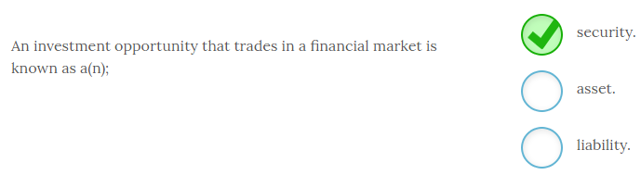

An investment opportunity that trades in a financial market is known as a **security**, or financial security. Stocks, bonds, futures, mutual funds and other derivative securities are all examples of financial assets.

Financial securities are assets but there are many assets that are not financial securities and do not trade in financial markets.

-------------------------------------------------------------------------------------------------------------------------------------------------------------------------------------------------------------

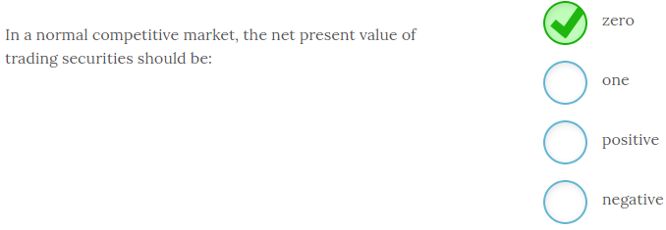

In a normal competitive market, the net present value of trading securities should be **zero**.

If buying a stock or bond presented a positive NPV, then investors would jump on that opportunity and push the price higher until the NPV was zero. So, any deviation from an NPV of zero will not last long due to arbitrage.

-------------------------------------------------------------------------------------------------------------------------------------------------------------------------------------------------------------

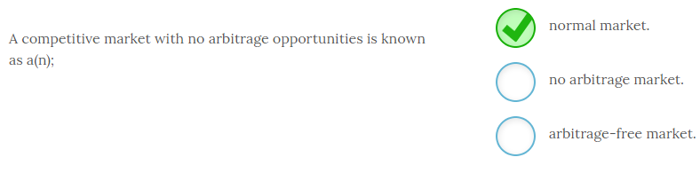

A competitive market with no arbitrage opportunities is known as a **normal market**. Most markets with a number of participants are normal markets since arbitrage opportunities are acted on rapidly and therefore disappear almost as soon as they appear. A market with arbitrage opportunities is therefore not the norm.

-------------------------------------------------------------------------------------------------------------------------------------------------------------------------------------------------------------

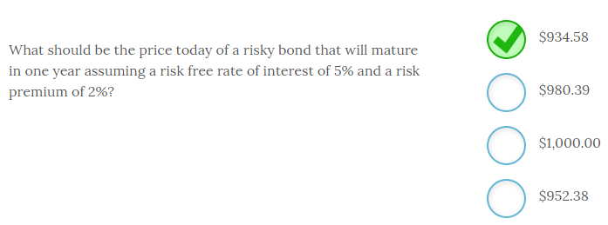

The price today of a risky bond that will mature in one year assuming a risk free rate of interest of 5% and a risk premium of 2% should be **$934.58**.

Since risky bonds do not pay interest, the value is merely the present value of the $1,000 cash flow you expect to receive in one year discounted back to the present using an interest rate commensurate with the bond’s risk. Since this bond is a risky bond, you need to use a discount rate of 7%, which is the sum of the risk free rate of 5% and the 2% risk premium. So, $1,000/1.07 = $934.58.

The risk free bond would be priced at $952.30 or $1,000/1.05. The bond would be priced at $1,000 assuming a zero percent discount rate and $980.39 if the interest rate was 2%.

-------------------------------------------------------------------------------------------------------------------------------------------------------------------------------------------------------------

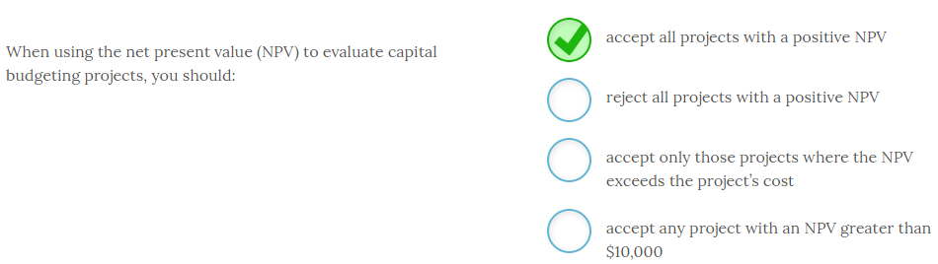

When using the net present value (NPV) to evaluate capital budgeting projects, you should **accept all projects with a positive NPV**.

NPV calculates the present value of the project’s expected cash flows and then subtracts the initial project cost or initial outlay. To calculate the present values, you should use a discount rate equivalent to the return you demand for that project. Therefore, when NPV = 0, you are earning exactly your required return. Any positive NPV means you are earning your required return plus some additional premium. For this reason, the decision rule for NPV is to accept all projects that have positive NPVs.

NPV is the best project evaluation tool to use in capital budgeting. It will always give the correct accept or reject decision given your cash flow projections. However, keep in mind that whether the decision is ultimately good or bad depends on the accuracy of the cash flow projections. In most cases, you will not know the answer to that until the life of the project is completed or well underway.

-------------------------------------------------------------------------------------------------------------------------------------------------------------------------------------------------------------

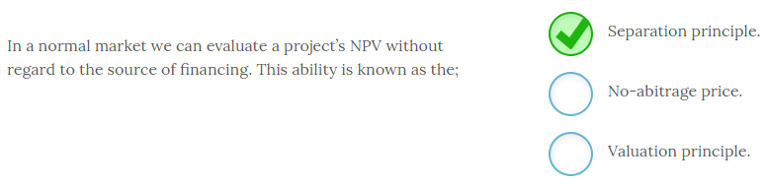

In a normal market we can evaluate a project’s NPV without regard to the source of financing. This ability is known as the **Separation principle**. In other words we can separate the financing and investment decision. This ability is due to the fact that the cost of financing is already factored into the discount rate used to compute the NPV.

The no-arbitrage price is the price of an asset in a normal market with no arbitrage opportunities.

-------------------------------------------------------------------------------------------------------------------------------------------------------------------------------------------------------------

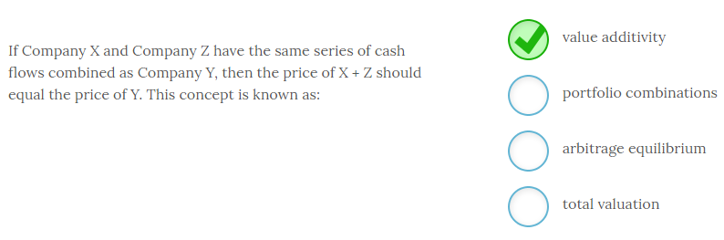

If Company X and Company Z have the same series of cash flows combined as Company Y, then the price of X + Z should equal the price of Y. This concept is known as **value additivity**.

Since Y has the same cash flows as X + Z, the value of Y has to be equal to the value of X + Z in a competitive market assuming the same level of risk. If these prices were out of balance, then an opportunity for arbitrage would exist. If prices are consistent with value additivity, then it is a no-arbitrage price that is in equilibrium.

The phrases ‘portfolio combinations’ and ‘total valuation’ have no meaning in this context.

# ---------------------------------------------------------------------------------------------------------------------------------------------------------------------

# Chapter 4

# ---------------------------------------------------------------------------------------------------------------------------------------------------------------------

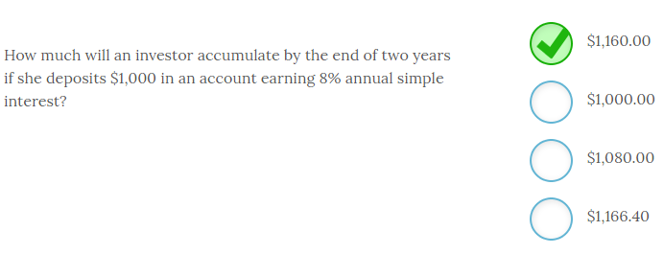

An investor will accumulate **$1,160.00**by the end of two years if she deposits $1,000 in an account earning 8% annual simple interest.

Simple interest refers to earning interest only on the original principal so this investor will earn $80 in interest ($1,000 x .08 = $80) for each year the $1,000 remains on deposit. In this case the $1,000 remains invested for two years so the investor will have the original $1,000 + $80 interest from year 1 + $80 interest from year two for a total of $1,160.

Compound interest, or the process of earning interest on the principal and reinvested interest, would result in the investor accumulating $1,166.40 by the end of two years. The process of computing the compound interest amount is FV = PV(1 + i)n = $1,000(1.08)2 = $1,166.40.

-------------------------------------------------------------------------------------------------------------------------------------------------------------------------------------------------------------

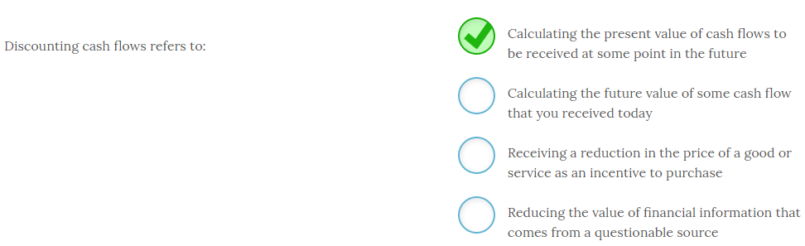

Discounting cash flows refers to **calculating the present value of cash flows to be received at some point in the future.** Discounting is the process of equating future cash flows to some value you would be indifferent to receiving today. For any positive interest rate that present value will always be lower than the sum of the future values because of the opportunity cost associated with the receipt of future cash flows.

While we often discount information received from questionable sources, or we may receive a customer discount on purchases, discounting cash flows always refers to calculating present values.

-------------------------------------------------------------------------------------------------------------------------------------------------------------------------------------------------------------

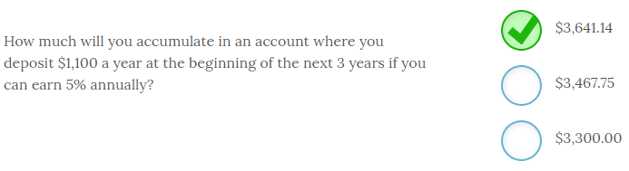

If you deposit $1,100 a year at the beginning of the next 3 years and you can earn 5% annually you will accumulate **$3,641.14** by the end of the third year. To calculate the FV of an annuity due you use the following financial calculator inputs;

So,

C = PMT = -$1,100

N = NPER = 3

I/Y = RATE = 5%

PV = 0

CPT FV = $3,467.38

For an annuity due you need to multiply this amount by (1 + r) to get the final result. So, $3,467.38(1.05) = $3,641.14. Remember that your calculator’s algorithm is set for end of period payments. Multiplying by (1 + r) corrects for the payment occurring at the beginning of the period.

Your financial calculator will also have a function that allows you to switch from BGN or END and compute the results without making the adjustment of multiplying (FV) by the factor (1 + r). When computing the PV of an annuity due you use one less period (NPER or N) and add the amount of the PMT or C to the answer you receive computing PV with one less period.

-------------------------------------------------------------------------------------------------------------------------------------------------------------------------------------------------------------

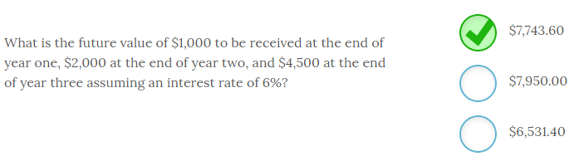

he future value of $1,000 to be received at the end of year one, $2,000 at the end of year two, and $4,500 at the end of year three assuming an interest rate of 6% is equal to **$7,743.60.**

To calculate the FV of an uneven cash flow stream you calculate the future values of the individual cash flows and sum those together. Look at the following timeline to help visualize the timing of these cash flows. In this case they are;

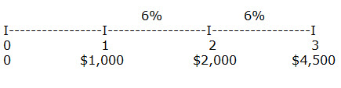

The year 1 cash flow (C) will earn 6% for 2 years, from the end of year one to the end of year 3 so FV C1 = $1,000(1.06)2 = $1,123.60. The year 2 cash flow will earn 6% for one year, from the end of year two to the end of year three so the FV C2 = $2,000(1.06) = $2,120.00. The future value of $4,500 to be received in year three is simply the $4,500.00.  Therefore the FV of the entire cash flow stream = $1,123.60 + $2,120.00 + $4,500.00 = $7,743.60. Keep in mind that the future value in this example would always exceed the sum of the actual cash flows ($7,500) for any positive interest rate.

-------------------------------------------------------------------------------------------------------------------------------------------------------------------------------------------------------------

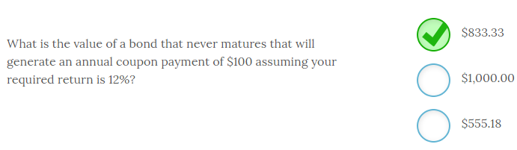

The value of a bond that never matures that will generate an annual coupon payment of $100, assuming a required return of 12%, is **$833.33.**

Perpetuity values are simply the cash flow divided by the required return so PV of a perpetuity = C/r

PV = $100/.12 = $833.33

You would be willing to pay $833.33 for this bond.

-------------------------------------------------------------------------------------------------------------------------------------------------------------------------------------------------------------

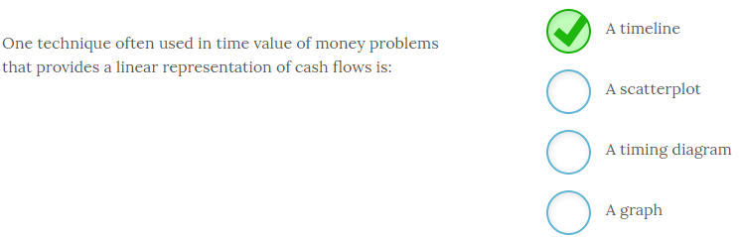

One technique often used in time value of money problems that provides a linear representation of cash flows is **a timeline**.  Timelines, like the one posted below, allow us to visually plot cash flows in order to help us solve financial problems.

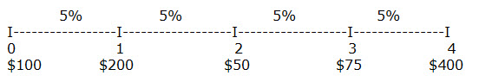

For example, look at the information plotted on this timeline and you can easily see where the cash flows occurred, the amount and direction of the cash flows, and the interest rates for each period. With this information you could easily calculate the answers to most financial questions related to this series of cash flows.

While scatterplots, diagrams, and graphs are all useful ways to summarize data they are not relevant to time value of money calculations of this nature.

-------------------------------------------------------------------------------------------------------------------------------------------------------------------------------------------------------------

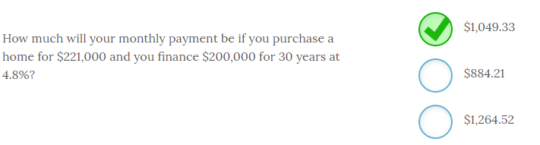

Your monthly payment will be **$1,049.33** if you purchase a home for $221,000 and you finance $200,000 for 30 years at 4.8%.

This calculation is simple with your financial calculator. You must first convert the interest rate and number of periods to monthly. So, N will be 30 years x 12 months per year = 360 months. The I/Y will be 4.8%/12 = .4% per month. Keep in mind you are only financing $200,000 of the purchase price of the home.

The calculator inputs will be;

PV = $200,000

N = NPER = 360

I/Y = RATE = .4

FV = 0

CPT PMT = -$1,049.33

You can use the formula method to solve this problem but the financial calculator makes this a very quick and easy solution. Learn to use your financial calculator.

-------------------------------------------------------------------------------------------------------------------------------------------------------------------------------------------------------------

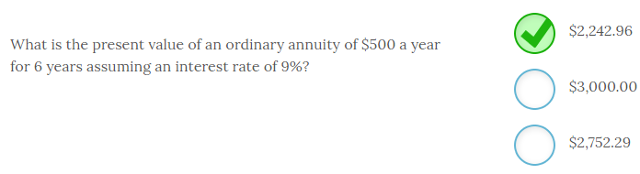

The present value of an ordinary annuity of $500 a year for 6 years assuming an interest rate of 9% is equal to **$2,242.96**. To calculate the PV of an annuity you use the following calculator keystrokes;

PMT = annuity payment

FV = future value

PV = present value

NPER = number of periods (Note that this is N on most financial calculators)

RATE = interest rate (Note that this key is I/Y on most financial calculators)

So, PMT = -$500; NPER = 6; RATE = 9; FV = 0; CPT PV = $2,242.96.

When using a financial calculator you need to put a negative sign in front of the PMT or the PV will be a negative number.

Ordinary annuities have the cash flows, or payments, occurring at the end of the period while an annuity due has the cash flows occurring at the beginning of the period.

-------------------------------------------------------------------------------------------------------------------------------------------------------------------------------------------------------------

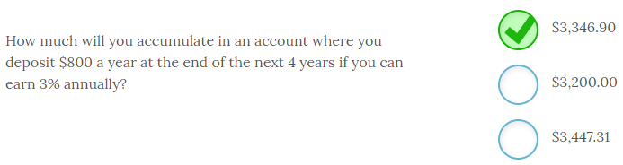

If you deposit $800 a year at the end of the next 4 years and you can earn 3% annually you will accumulate **$3,346.90** by the end of the fourth year. To calculate the FV of an ordinary annuity you use the following financial calculator inputs;

PMT = annuity payment

FV = future value

PV = present value

NPER = number of periods (Note that this is N on most financial calculators)

RATE = interest rate (Note that this key is I/Y on most financial calculators)

So, PMT = -$800; PV = 0; NPER = 4; RATE = 3; CPT FV = $3,346.90

Since you are depositing $800 per year you need to put a negative sign in front of the PMT since it is a cash outflow.

Most calculators require you to input the missing values as a zero with the exception of the value you are solving for. On a financial calculator the CPT key is compute.

-------------------------------------------------------------------------------------------------------------------------------------------------------------------------------------------------------------

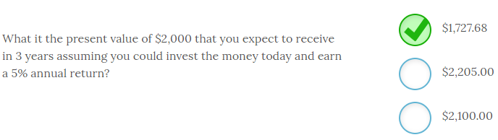

The present value of $2,000 that you expect to receive in 3 years assuming you could invest the money today and earn a 5% annual return is equal to **$1,727.68.**

To calculate the PV of a single sum you use the following formula;

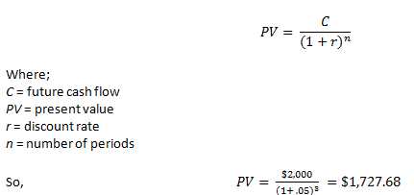

Always consider whether your answer is even possible. For example a present value will always be less than the future value for any positive rate of interest. Remember to use a timeline to identify the timing and amount of each cash flow.

-------------------------------------------------------------------------------------------------------------------------------------------------------------------------------------------------------------

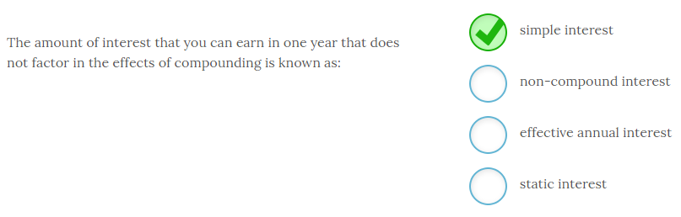

The amount of interest that you can earn in one year that does not factor in the effects of compounding is known as **simple interest**.

The simple interest rate is also often known as the APR or annual percentage rate. Conversely, compound interest rates incorporate the impact of compounding frequencies that include semiannual, quarterly, monthly or daily.

Simple interest may also be listed as the stated rate, quoted rate or nominal rate. None of these rates consider the impact of compounding.

-------------------------------------------------------------------------------------------------------------------------------------------------------------------------------------------------------------

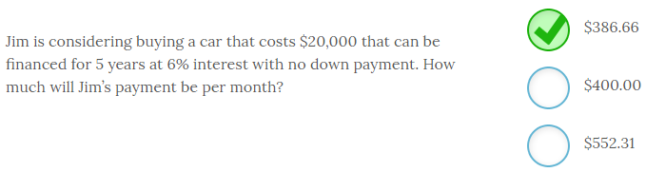

Jim’s monthly payment on a 5-year $20,000 loan at 6% interest will be **$386.66**. In order to calculate a payment you use the following financial calculator inputs;

PMT = annuity payment

FV = future value

PV = present value

NPER = number of periods (Note that this is N on most financial calculators)

RATE = interest rate (Note that this key is I/Y on most financial calculators)

So, PV = -$20,000; RATE = 6/12 months = .5; NPER = 5 year x 12 months per year = 60 months; FV = 0; CPT PMT = $386.66

Note that you must convert NPER to the number of months and RATE to a monthly interest rate. The present value is the cost of the car today, or the amount financed.

-------------------------------------------------------------------------------------------------------------------------------------------------------------------------------------------------------------  
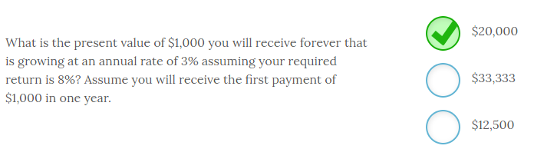

The present value of $1,000 you will receive forever that is growing at an annual rate of 3% assuming your required return is 8% and assuming you will receive the first payment of $1,000 in one year is **$20,000**. To compute the answer you use the following formula;

PV = C/(r –g) where

C = the first cash flow you will receive at the end of the next period

r = required return

g = growth rate

So, PV = $1,000/(.08 - .03) = $1,000/.05 = $20,000.

-------------------------------------------------------------------------------------------------------------------------------------------------------------------------------------------------------------

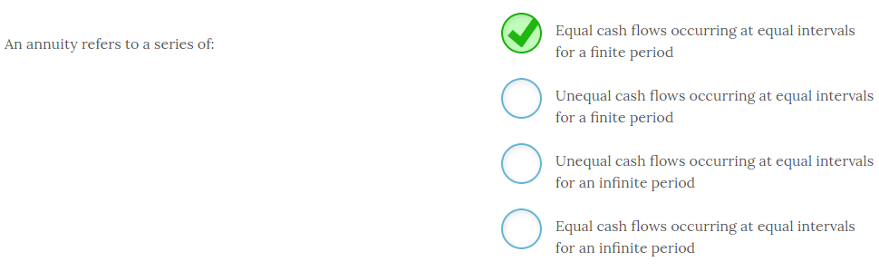

An annuity refers to a series of **equal cash flows occurring at equal intervals for a finite period.** Common annuities are car payments and mortgages. Another example of an annuity would be a series of monthly deposits you make in order to accumulate $15,000 over the next five years for a down payment on a house. In every case you will pay (or receive) an equal payment for a fixed number of months (equal intervals) to repay the loan or accumulate some amount of money.

Annuities that extend for an infinite period are known as perpetuities. And, any time the cash flows are not equivalent it is not an annuity but instead just a series of irregular or uneven cash flows.

It is important to be able to recognize an annuity because identifying whether a series of cash flows contains an annuity will make calculating present values and future values easier.

-------------------------------------------------------------------------------------------------------------------------------------------------------------------------------------------------------------

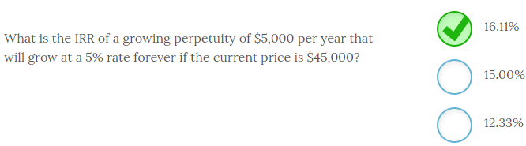

The IRR of a growing perpetuity of $5,000 per year that will grow at a 5% rate forever if the current price is $45,000 is **16.11%**.

To compute the IRR you use the following formula;

IRR of a growing perpetuity = (C/P) + g

So in this case, ($5,000/$45,000) + .05 = .1611 or 16.11%

-------------------------------------------------------------------------------------------------------------------------------------------------------------------------------------------------------------

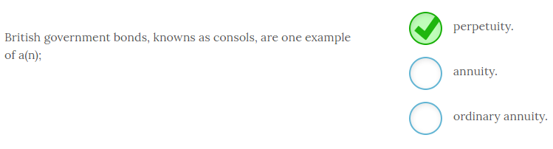

British government bonds, knowns as consols, are one example of a **perpetuity**. Perpetuities are equal cash flow streams that occur at equal intervals forever, or perpetually. Annuities are equal cash flow streams that occur at equal intervals and have a finite maturity. For an ordinary annuity the cash flow occurs at the end of each period, for example the end of each month or year.

An annuity due has cash flows that occur at the beginning of each interval or period.

-------------------------------------------------------------------------------------------------------------------------------------------------------------------------------------------------------------

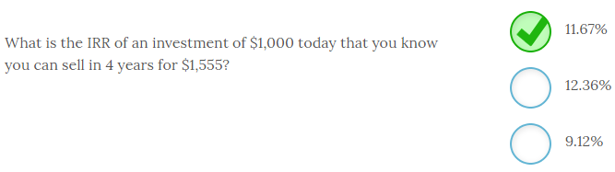

The IRR of an investment of $1,000 today that you know you can sell in 4 years for $1,555 is **11.67%**. The easiest way to solve this problem is to use your financial calculator with the following inputs;

PV = -$1,000; FV = $1,555; NPER or N = 4; PMT or C = 0; CPT I/Y or RATE = 11.67%.

You can easily check your result by using the FV formula for a single sum and plugging the IRR in as your interest rate. So, $1,000(1.1167)4 = $1,555.

-------------------------------------------------------------------------------------------------------------------------------------------------------------------------------------------------------------

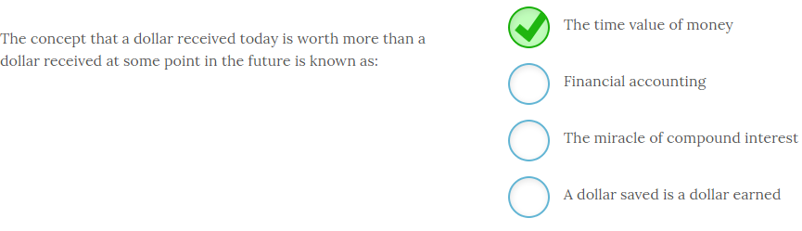

The concept that a dollar received today is worth more than a dollar received at some point in the future is known as **the time value of money.** The time value of money is one of the basic underlying principles of finance. This concept holds because we all exhibit a preference for having cash today instead of at some point in the future.

You can illustrate this point by asking all your friends if they would prefer you give them $100 today or $100 one year from now. All would prefer the $100 today because there is an opportunity cost of not receiving the money today and also a risk associated with not receiving the money today. They could deposit the money today and earn interest that would result in more than $100 at the end of the year, or they could decide to spend it today and it would buy more than it will in one year simply due to inflation. And what happens if you fall on financial hard times and could not disburse the $100 in one year? For these reasons I think you will agree there is a time value associated with the receipt of money.

-------------------------------------------------------------------------------------------------------------------------------------------------------------------------------------------------------------

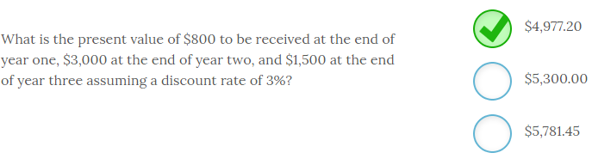

The present value of $800 to be received at the end of year one, $3,000 at the end of year two, and $1,500 at the end of year three assuming a discount rate of 3% is **$4,977.20.**

To calculate the PV of an uneven cash flow stream you calculate the present values of the individual cash flows and sum those together. Look at the following timeline to help visualize the timing of these cash flows. In this case they are;

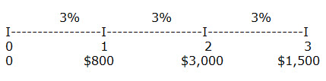

https://kf1.amplifire.com/amp/Resource?path=7bcc7a18-db97-41bb-b076-c23a5b0052ba/00/0062719e-f585-4b39-b615-3278cc7be925.png&originalFileName=Cashflow2

So, the PV of this cash flow stream = 776.70 + 2,827.79 + 1,372.71 = $4,977.20. Keep in mind that the present value in this example would always be less than the sum of the actual cash flows ($5,300) for any positive interest rate.

-------------------------------------------------------------------------------------------------------------------------------------------------------------------------------------------------------------

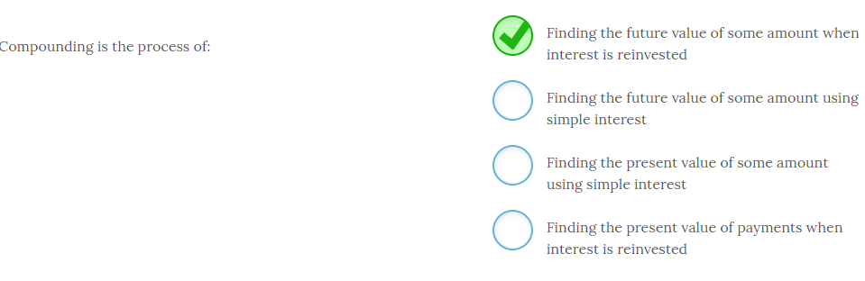

Compounding is the process of **finding the future value of some amount when interest is reinvested**.

Compounding refers to the process of adding interest back to the original principal and then earning returns on both the original principal and reinvested interest. Conversely, simple interest refers to the process of earning additional interest ONLY on the original principal and not on reinvested interest.

Compounding always refers to some point in the future so it will always deal with finding future values.

Discounting is the reverse of that process and deals with finding the present value of some amount.

-------------------------------------------------------------------------------------------------------------------------------------------------------------------------------------------------------------

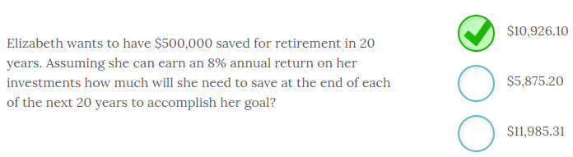

Elizabeth wants to have $500,000 saved for retirement in 20 years. Assuming she can earn an 8% annual return on her investments she will need to deposit **$10,926.10** at the end of each of the next 20 years to accomplish her goal.

Fluency with your financial calculator makes this problem easy to solve. Elizabeth has a future value in mind that she needs to accumulate in order to retire. She has a forecast annual percentage return and a time horizon in mind. With these inputs she can compute the payment she needs to make at the end of every year to accomplish her goal.

So,

FV = $500,000

N = NPER = 20

I/Y = RATE = 8%

PV = 0

CPT PMT = -$10,926.10

-------------------------------------------------------------------------------------------------------------------------------------------------------------------------------------------------------------

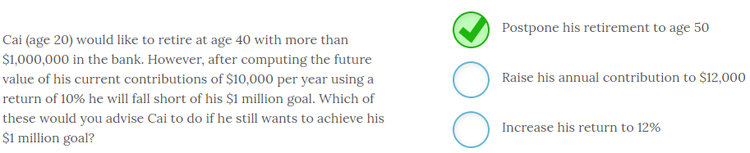

Cai (age 20) would like to retire at age 40 with more than $1,000,000 in the bank. However, after computing the future value of his current contributions of $10,000 per year using a return of 10% he will fall short of his $1 million goal. Of these options the only one that will allow Cai to achieve his $1 million goal is to **postpone his retirement to age 50.** However, you can see the FV will increase as the amount of the payment or interest rate increases, as well as time.

You can also solve for NPER or N and see how much past the age of 40 Cai would need to work. It will not be the entire 10 year period if his assumptions hold.

While increasing his return could increase his final amount it also increases risk and may not be feasible beyond some point.

-------------------------------------------------------------------------------------------------------------------------------------------------------------------------------------------------------------

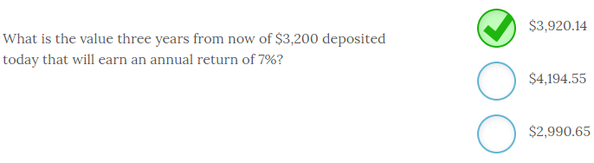

The value three years from now of $3,200 deposited today that will earn an annual return of 7% is **$3,920.14**. To calculate the FV of a single sum you use the following formula;

*FVn = C x (1 + r)n*where;

*FV* = future value

*C* = present value

*r* = interest rate

*n* = number of periods

So, *FV* = $3,200(1 + .07)3 = $3,200(1.22504) = $3,920.14.

Always consider whether your answer is even possible. For example a future value will always be more than the present value for any positive rate of interest. Remember to use a timeline to identify the timing and amount of each cash flow.

-------------------------------------------------------------------------------------------------------------------------------------------------------------------------------------------------------------

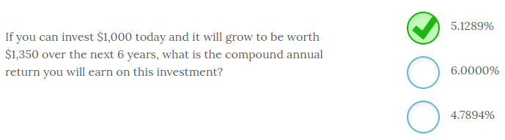

If you can invest $1,000 today and it will grow to be worth $1,350 over the next 6 years, the compound annual return you will earn on this investment is **5.1289%** per year. Using your financial calculator makes this problem easy to solve after you identify the appropriate inputs.

So,

PV = -$1,000 since you are depositing the money.

FV = $1,350

N = 6

PMT = 0

CPT I/Y or RATE = 5.1289% annual return.

You can easily check your result by the using the following formula for future value of a single sum. *FV = PV(1 + r)n* so $1,000(1.051289)6 = $1,350.08.

-------------------------------------------------------------------------------------------------------------------------------------------------------------------------------------------------------------

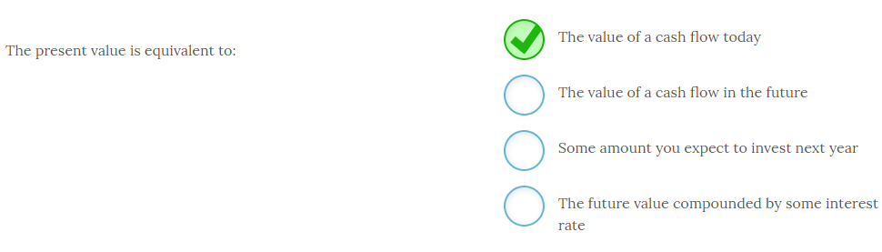

The present value is equal to **the value of a cash flow today**. When you calculate the present value of any cash flow you are finding the amount of money you would be indifferent to receiving today in lieu of some future cash flow. We often refer to the present value as time period zero to indicate that is the value now.

Any references to a value at some point in the future will always refer to future values.

# ---------------------------------------------------------------------------------------------------------------------------------------------------------------------

# Chapter 5

# ---------------------------------------------------------------------------------------------------------------------------------------------------------------------

-------------------------------------------------------------------------------------------------------------------------------------------------------------------------------------------------------------

-------------------------------------------------------------------------------------------------------------------------------------------------------------------------------------------------------------

-------------------------------------------------------------------------------------------------------------------------------------------------------------------------------------------------------------

-------------------------------------------------------------------------------------------------------------------------------------------------------------------------------------------------------------

-------------------------------------------------------------------------------------------------------------------------------------------------------------------------------------------------------------

-------------------------------------------------------------------------------------------------------------------------------------------------------------------------------------------------------------

-------------------------------------------------------------------------------------------------------------------------------------------------------------------------------------------------------------

-------------------------------------------------------------------------------------------------------------------------------------------------------------------------------------------------------------

-------------------------------------------------------------------------------------------------------------------------------------------------------------------------------------------------------------

-------------------------------------------------------------------------------------------------------------------------------------------------------------------------------------------------------------

-------------------------------------------------------------------------------------------------------------------------------------------------------------------------------------------------------------

-------------------------------------------------------------------------------------------------------------------------------------------------------------------------------------------------------------

-------------------------------------------------------------------------------------------------------------------------------------------------------------------------------------------------------------

-------------------------------------------------------------------------------------------------------------------------------------------------------------------------------------------------------------

-------------------------------------------------------------------------------------------------------------------------------------------------------------------------------------------------------------

-------------------------------------------------------------------------------------------------------------------------------------------------------------------------------------------------------------

-------------------------------------------------------------------------------------------------------------------------------------------------------------------------------------------------------------

-------------------------------------------------------------------------------------------------------------------------------------------------------------------------------------------------------------

-------------------------------------------------------------------------------------------------------------------------------------------------------------------------------------------------------------

-------------------------------------------------------------------------------------------------------------------------------------------------------------------------------------------------------------

-------------------------------------------------------------------------------------------------------------------------------------------------------------------------------------------------------------

-------------------------------------------------------------------------------------------------------------------------------------------------------------------------------------------------------------

-------------------------------------------------------------------------------------------------------------------------------------------------------------------------------------------------------------

-------------------------------------------------------------------------------------------------------------------------------------------------------------------------------------------------------------

-------------------------------------------------------------------------------------------------------------------------------------------------------------------------------------------------------------

-------------------------------------------------------------------------------------------------------------------------------------------------------------------------------------------------------------

-------------------------------------------------------------------------------------------------------------------------------------------------------------------------------------------------------------

-------------------------------------------------------------------------------------------------------------------------------------------------------------------------------------------------------------

-------------------------------------------------------------------------------------------------------------------------------------------------------------------------------------------------------------

-------------------------------------------------------------------------------------------------------------------------------------------------------------------------------------------------------------

-------------------------------------------------------------------------------------------------------------------------------------------------------------------------------------------------------------

-------------------------------------------------------------------------------------------------------------------------------------------------------------------------------------------------------------

-------------------------------------------------------------------------------------------------------------------------------------------------------------------------------------------------------------

-------------------------------------------------------------------------------------------------------------------------------------------------------------------------------------------------------------

-------------------------------------------------------------------------------------------------------------------------------------------------------------------------------------------------------------

-------------------------------------------------------------------------------------------------------------------------------------------------------------------------------------------------------------

-------------------------------------------------------------------------------------------------------------------------------------------------------------------------------------------------------------

-------------------------------------------------------------------------------------------------------------------------------------------------------------------------------------------------------------

-------------------------------------------------------------------------------------------------------------------------------------------------------------------------------------------------------------

-------------------------------------------------------------------------------------------------------------------------------------------------------------------------------------------------------------

-------------------------------------------------------------------------------------------------------------------------------------------------------------------------------------------------------------

-------------------------------------------------------------------------------------------------------------------------------------------------------------------------------------------------------------

-------------------------------------------------------------------------------------------------------------------------------------------------------------------------------------------------------------

-------------------------------------------------------------------------------------------------------------------------------------------------------------------------------------------------------------

-------------------------------------------------------------------------------------------------------------------------------------------------------------------------------------------------------------

-------------------------------------------------------------------------------------------------------------------------------------------------------------------------------------------------------------

-------------------------------------------------------------------------------------------------------------------------------------------------------------------------------------------------------------

-------------------------------------------------------------------------------------------------------------------------------------------------------------------------------------------------------------

-------------------------------------------------------------------------------------------------------------------------------------------------------------------------------------------------------------

-------------------------------------------------------------------------------------------------------------------------------------------------------------------------------------------------------------

-------------------------------------------------------------------------------------------------------------------------------------------------------------------------------------------------------------

-------------------------------------------------------------------------------------------------------------------------------------------------------------------------------------------------------------

-------------------------------------------------------------------------------------------------------------------------------------------------------------------------------------------------------------

-------------------------------------------------------------------------------------------------------------------------------------------------------------------------------------------------------------

-------------------------------------------------------------------------------------------------------------------------------------------------------------------------------------------------------------

-------------------------------------------------------------------------------------------------------------------------------------------------------------------------------------------------------------

-------------------------------------------------------------------------------------------------------------------------------------------------------------------------------------------------------------

-------------------------------------------------------------------------------------------------------------------------------------------------------------------------------------------------------------

-------------------------------------------------------------------------------------------------------------------------------------------------------------------------------------------------------------

-------------------------------------------------------------------------------------------------------------------------------------------------------------------------------------------------------------

-------------------------------------------------------------------------------------------------------------------------------------------------------------------------------------------------------------

-------------------------------------------------------------------------------------------------------------------------------------------------------------------------------------------------------------

-------------------------------------------------------------------------------------------------------------------------------------------------------------------------------------------------------------

-------------------------------------------------------------------------------------------------------------------------------------------------------------------------------------------------------------

-------------------------------------------------------------------------------------------------------------------------------------------------------------------------------------------------------------

-------------------------------------------------------------------------------------------------------------------------------------------------------------------------------------------------------------

-------------------------------------------------------------------------------------------------------------------------------------------------------------------------------------------------------------

-------------------------------------------------------------------------------------------------------------------------------------------------------------------------------------------------------------

-------------------------------------------------------------------------------------------------------------------------------------------------------------------------------------------------------------

-------------------------------------------------------------------------------------------------------------------------------------------------------------------------------------------------------------

-------------------------------------------------------------------------------------------------------------------------------------------------------------------------------------------------------------

-------------------------------------------------------------------------------------------------------------------------------------------------------------------------------------------------------------

-------------------------------------------------------------------------------------------------------------------------------------------------------------------------------------------------------------

-------------------------------------------------------------------------------------------------------------------------------------------------------------------------------------------------------------

-------------------------------------------------------------------------------------------------------------------------------------------------------------------------------------------------------------

-------------------------------------------------------------------------------------------------------------------------------------------------------------------------------------------------------------

-------------------------------------------------------------------------------------------------------------------------------------------------------------------------------------------------------------

-------------------------------------------------------------------------------------------------------------------------------------------------------------------------------------------------------------

-------------------------------------------------------------------------------------------------------------------------------------------------------------------------------------------------------------

-------------------------------------------------------------------------------------------------------------------------------------------------------------------------------------------------------------

-------------------------------------------------------------------------------------------------------------------------------------------------------------------------------------------------------------

-------------------------------------------------------------------------------------------------------------------------------------------------------------------------------------------------------------

-------------------------------------------------------------------------------------------------------------------------------------------------------------------------------------------------------------

-------------------------------------------------------------------------------------------------------------------------------------------------------------------------------------------------------------

-------------------------------------------------------------------------------------------------------------------------------------------------------------------------------------------------------------

-------------------------------------------------------------------------------------------------------------------------------------------------------------------------------------------------------------

-------------------------------------------------------------------------------------------------------------------------------------------------------------------------------------------------------------

-------------------------------------------------------------------------------------------------------------------------------------------------------------------------------------------------------------

-------------------------------------------------------------------------------------------------------------------------------------------------------------------------------------------------------------

-------------------------------------------------------------------------------------------------------------------------------------------------------------------------------------------------------------

-------------------------------------------------------------------------------------------------------------------------------------------------------------------------------------------------------------

-------------------------------------------------------------------------------------------------------------------------------------------------------------------------------------------------------------

-------------------------------------------------------------------------------------------------------------------------------------------------------------------------------------------------------------

-------------------------------------------------------------------------------------------------------------------------------------------------------------------------------------------------------------

-------------------------------------------------------------------------------------------------------------------------------------------------------------------------------------------------------------

-------------------------------------------------------------------------------------------------------------------------------------------------------------------------------------------------------------

-------------------------------------------------------------------------------------------------------------------------------------------------------------------------------------------------------------

-------------------------------------------------------------------------------------------------------------------------------------------------------------------------------------------------------------

-------------------------------------------------------------------------------------------------------------------------------------------------------------------------------------------------------------

-------------------------------------------------------------------------------------------------------------------------------------------------------------------------------------------------------------

-------------------------------------------------------------------------------------------------------------------------------------------------------------------------------------------------------------

-------------------------------------------------------------------------------------------------------------------------------------------------------------------------------------------------------------

-------------------------------------------------------------------------------------------------------------------------------------------------------------------------------------------------------------

-------------------------------------------------------------------------------------------------------------------------------------------------------------------------------------------------------------

-------------------------------------------------------------------------------------------------------------------------------------------------------------------------------------------------------------

-------------------------------------------------------------------------------------------------------------------------------------------------------------------------------------------------------------

-------------------------------------------------------------------------------------------------------------------------------------------------------------------------------------------------------------

-------------------------------------------------------------------------------------------------------------------------------------------------------------------------------------------------------------

-------------------------------------------------------------------------------------------------------------------------------------------------------------------------------------------------------------

-------------------------------------------------------------------------------------------------------------------------------------------------------------------------------------------------------------